Low Level Design

**Expenditure Data Analysis**

|  |  |
| --- | --- |
| **Written By** | Adil Shaikh |
| **Document Version** | 0.1 |
| **Last Revised Date** |  |

# DOCUMENT CONTROL

**Change Record:**

|  |  |  |  |
| --- | --- | --- | --- |
| **VERSION** | **DATE** | **AUTHOR** | **COMMENTS** |
| 0.1 | 23- Oct - 2021 | Adil Shaikh | Introduction and architecture defined |
| 0.2 | 24 - Oct - 2021 | Adil Shaikh | Architecture & Architecture description appended and updated. |
|  |  |  |  |
|  |  |  |  |

**Reviews:**

|  |  |  |  |  |  |  |  |  |
| --- | --- | --- | --- | --- | --- | --- | --- | --- |
| **VERSION** | **DATE** |  | **REVIEWER** |  | **COMMENTS** | | |  |
| 0.2 | 25- Oct -  2021 |  | Adil Shaikh |  | Unit test cases to be added | | |  |
| **Approval Status:** | |  |  |  |  | | |  |
| **VERSION** | **REVIEW DATE** |  | **REVIEWED BY** |  |  | **APPROVED BY** |  | **COMMENTS** |
|  |  |  | |  | |  |  | |

# Contents

|  |  |  |
| --- | --- | --- |
| 1 | Introduction | 4 |
| 1.1 | What is Low-Level Design | 4 |
| 1.2 | Scope | 4 |
| 2 | Architecture | 5 |
| 3 | Architecture Description | 7 |
| 3.1 | Data Description | 7 |
| 3.2 | Web Scraping | 8 |
| 3.3 | Data Transformation |  |
| 3.4 | Data insertion |  |
| 3.5 | Export Data from Database |  |
| 3.6 | Deployment |  |
| 4 | Unit Test cases |  |

## 

# 1. Introduction

**1.1 What is Low-Level design document?**

The goal of the LDD or Low-level design document (LLDD) is to give the internal logic design of the actual program code for the House Price Prediction dashboard. LDD describes the class diagrams with the methods and relations between classes and programs specs. It describes the modules so that the programmer can directly code the program from the document.

## 1.2 Scope

Low-level design (LLD) is a component-level design process that follows a step-by-step refinement process. The process can be used for designing data structures, required software architecture, source code and ultimately, performance algorithms. Overall, the data organization may be defined during requirement analysis and then refined during data design work.

# 2. Architecture

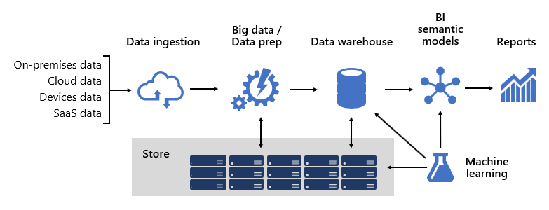

# PowerBI Server Architecture

|  |  |
| --- | --- |
| Power BI architecture is a service built on top of Azure. There are multiple data sources that Power BI can connect to. Power BI Desktop allows you to create reports and data visualizations on the dataset. Power BI gateway is connected to on-premise data sources to get continuous data for reporting and analytics. | |
| The following diagram shows PowerBI Server’s architecture: |  |

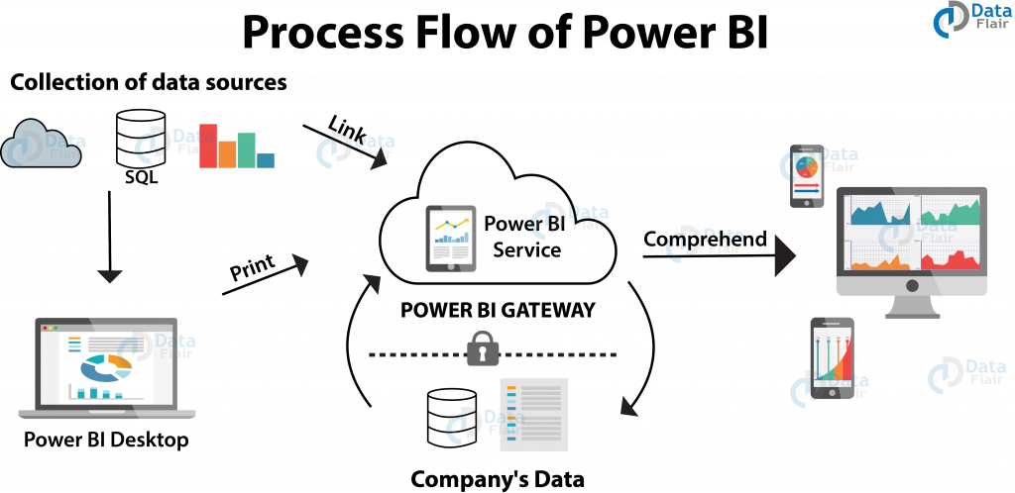

PowerBi Server is internally managed by the multiple server processes.

**1) Power Query**

Power Query is the data transformation and mash up the engine. It enables you to discover, connect, combine, and refine data sources to meet your analysis need. It can be downloaded as an add-in for Excel or can be used as part of the Power BI Desktop.

## 2) Power Pivot

Power Pivot is a data modeling technique that lets you create data models, establish relationships, and create calculations. It uses Data Analysis Expression (DAX) language to model simple and complex data.

3) **Power View**

## Power View is a technology that is available in Excel, Sharepoint, SQL Server, and Power BI. It lets you create interactive charts, graphs, maps, and other visuals that bring your data to life. It can connect to data sources and filter data for each data visualization element or the entire report.

### 4) **Power Map**

Microsoft's Power Map for Excel and Power BI is a 3-D data visualization tool that lets you map your data and plot more than a million rows of data visually on Bing maps in 3-D format from an Excel table or Data Model in Excel. Power Map works with Bing maps to get the best visualization based on latitude, longitude, or country, state, city, and street address information.

### **5) Power BI Desktop**

Power BI Desktop is a development tool for Power Query, Power Pivot, and Power View. With Power BI Desktop, you have everything under the same solution, and it is easier to develop BI and data analysis experience.

.

# 3. Architecture Description

## 3.1. Data Description

The Dataset contains Sales of Company based on the Product , Sales , Profit and Cost

1. Item : Product Sell by Company
2. Sale Amount: Selling Price of Product
3. Sale Margin Amount: Overall Profit from Product.
4. Sale Cost Amount : Cost Price of Product
5. Discount : Discount Price on Product

## 3.2. Web Scrapping

Web scraping is a technique to automatically extract content and data from websites using bots. It is also known as web data extraction or web harvesting. Web scrapping is made simple now days, many tools are used for web scrapping. Some of python libraries used for web scrapping are Beautiful Soup, Scrapy, Selenium, etc.

## 3.3. Data Transformation

In the Transformation Process, we will convert our original datasets with other necessary attributes format. And will merge it with the Scrapped dataset.

## 3.4. Data Insertion

1. Create the excel file dump the Data into Excel file in xlsx or csv format
2. Data Insertion can be done by using SQL server

## 3.5 Make the Excel connection and set up the data source

**Step 1: Configuring Power BI**

Launch Power BI on your workstation and select Excel from the connect column on the left. This will open a dialogue box where you need to select the file.

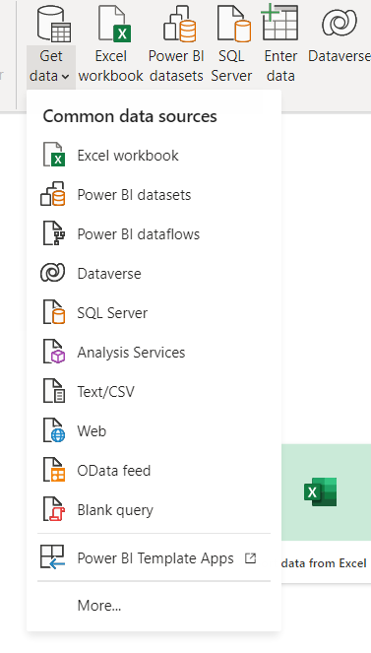

**Step 2: Configuring Data Source**

Select the data source and Load.

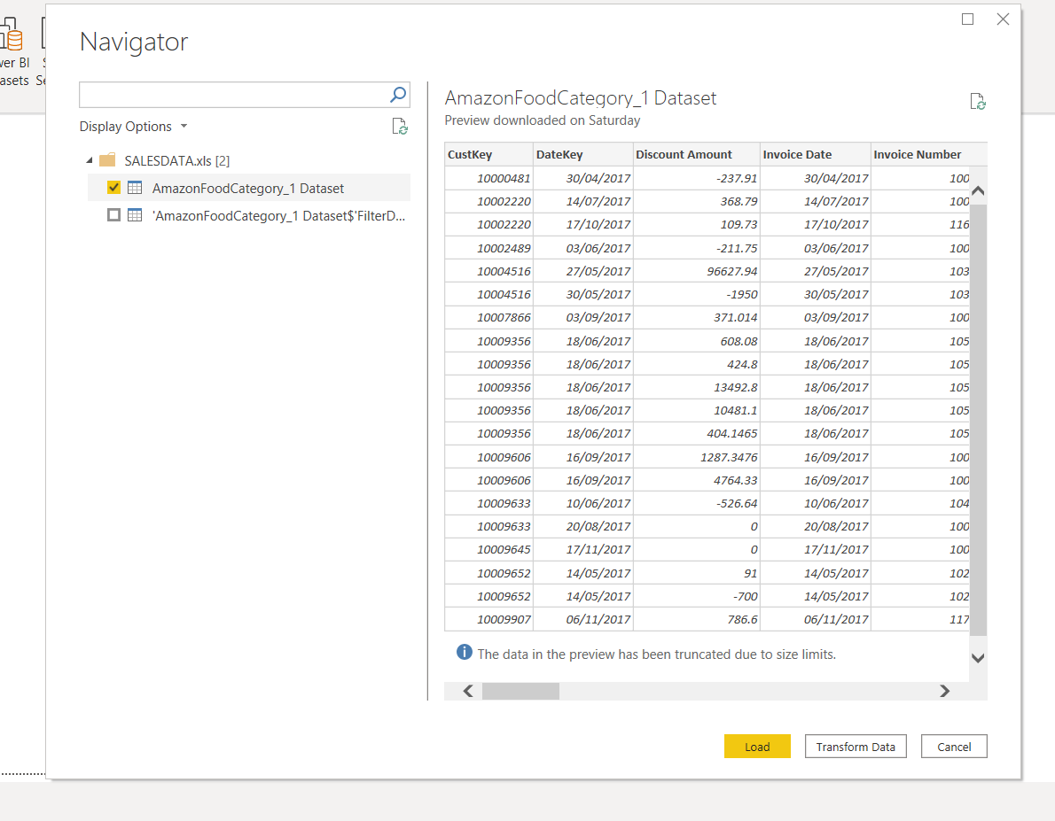

## 3.5. Export Data from Database

Data Export from Database - The data in a stored database is exported as a CSV file to be used for Data Pre-processing.

**3.6 Deployment.**

Once you’ve completed your dashboard, follow these steps:**- Server,Save to device**

You will need an Work Email for saving in server.

# 4. Unit Test Cases

|  |  |
| --- | --- |
| **TEST CASE DESCRIPTION** | **EXPECTED RESULTS** |
| Year, Month, Quarter Slicer | When clicked on the slicer, a dropdown should occur which has various parameters month and Quarter. |
| Sales Amount , Margin, profit  Quantity | When clicked on the year, it will show the the total Sales Amount,  Margin , Profit Quantity , you can also see Monthly and Quarter Data. |
| Top 5 | Top 5 sales amount and Sales Margin on the basis of Product |
| Cost and Discount | This is an important part you can see the Total Cost , Cost per  Product , Profit per Product and Discount per Product |